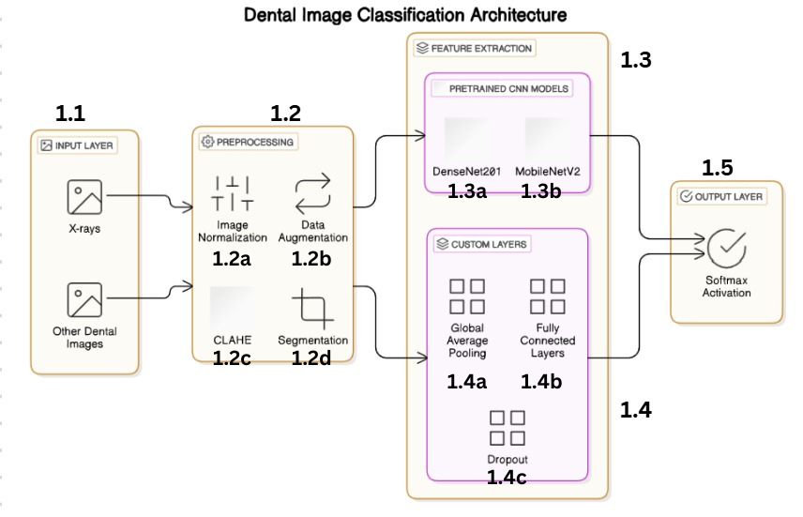

Fig.1. A Schematic Representation of Xray and Oral Dental Diagnosis.

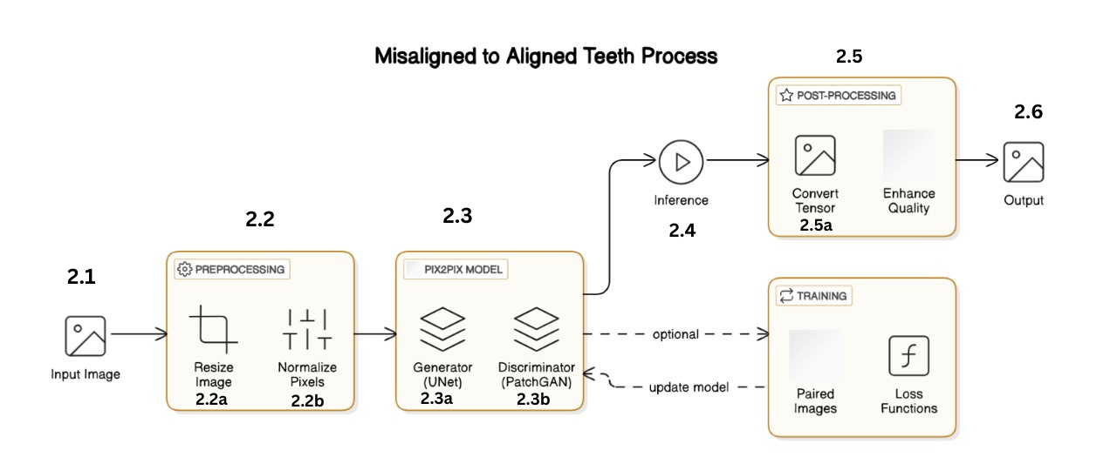

Fig.2. A Schematic Representation of Orthodontic Treatment.

